

March 3, 2015

Re: Expansion of the Concentrated 786 Overlay with NPA 305 (Florida)

Dear Customer,

On July 18, 2014, the Florida Public Service Commission, (FPSC) approved the expansion of the
305-786 NPA concentrated overlay into Monroe County for the remaining Florida Keys rate
center which includes communities such as Big Pine Key, Islamorada, Key Colony Beach, Key
Largo, Key West, Layton, Marathon, North Key Largo and Sugar Loaf Shores.

Implementation of Relief Plan
Implementation of the overlay of the 786 NPA is as follows:

In preparation for the expansion of the overlay code and mandatory 10 digit dialing, a permissive
dialing period has been in place since August 1, 2001. During this time subscribers in the
geographic area to be served by the overlay expansion, have been encouraged to dial 10 digits
(i.e. NPA + NXX + XXXX) for all local calls. Beginning on April 18, 2015, at 12:01 a.m. (ET)
all local calls within and between the 305 and 786 NPAs in the overlay area will require 10-digit
dialing. Implementation of the overlay expansion of the 786 NPA is as follows:

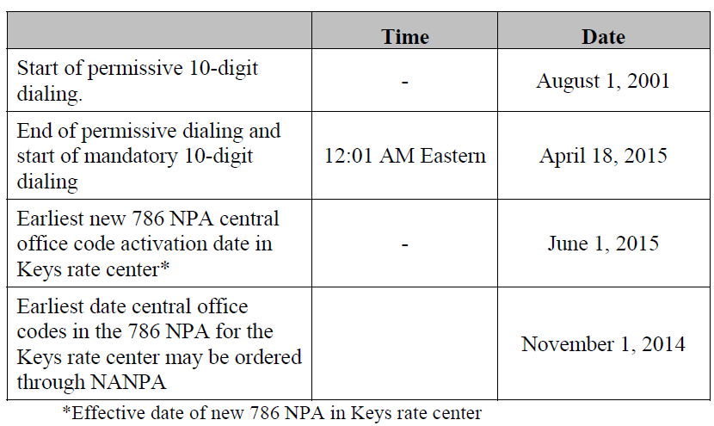
During the permissive dialing period, subscribers in the Keys area may dial local calls within the
overlay area on either a 7-digit or 10-digit basis, but will be encouraged to dial 10-digits. After
the permissive period ends, all calls must be dialed using 10-digits.

PHASE I
Permissive Dialing Date – Began August 1, 2001: During the permissive dialing period, subscribers may dial local calls within the overlay area on either a 7-digit or 10-digit basis, but will be encouraged to dial 10-digits. After the permissive period ends, all calls must be dialed using 10-digits.
When preparing for overlay area code relief, carriers are strongly encouraged to prepare their switches to begin sending 10 digits prior to the mandatory 10-digit dialing conversion date for customers.

PHASE II
Mandatory 10 Digit Dialing Date – Begins April 18, 2015: All callers must dial local calls with 10 digits. If you inadvertently dial 7 digits, your call will not be completed and a recording will prompt you to hang up and dial again.

Dialing Plan
Coincident with the introduction of mandatory 10-digit dialing, the dialing plan for the 305 and
786 NPAs, including the Florida Keys area, will be as follows:
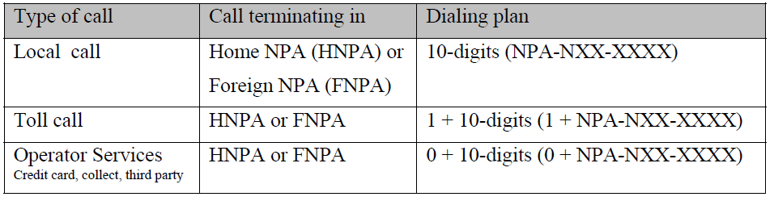
To prepare for this overlay, please note the following:

- Notify your clients, vendors, domestic and international of your new area code.
- Inform employees, customers, and co-workers.
- Changes in telephone equipment should be directed to the equipment vendor.
- Utilize the applicable test number to make sure your equipment recognizes the new area code.
- Update all correspondence, such as stationery, business cards, checks, brochures, promotional items, internet web pages, catalogs, directory listings.
- Reprogram features such as Auto-Dialing, Speed dialing, and Call Forwarding.
- Reprogram security doors and gate systems.
- Contact your service provider to update your cell phone and other wireless communications.
- Internet dial-up connection may need reprogramming or to be upgraded.
- Notify Alarm system providers of the new area code + telephone number so they can update their records and equipment as needed.

The area code overlay will not affect the cost of a call. Costs incurred for updating systems and revising printed materials is the responsibility of the customer. The directory listings (white pages) will be updated by the telecommunications industry. Listings appearing in other directories will be the responsibility of the customer.

If you have any additional questions, please contact your Premier Specialist or Customer Service 1-866-847-5500.

